**Potato Late Blight**

The Potato Late Blight risk uses index ratings in form of “Disease Severity Value” (DSV) which is based on conditions that are favourable for the development of late blight. Two models; Wisdom and TomCast are being used and both models uses 15-minute Temperature and Relative Humidity Data as well as hourly rainfall. The number of hours of recorded precipitation within a 24-hour period as a proxy for leaf wetness. The “model day” runs from noon to noon (12:15 time slot to include 12:00 the next day).

The Wisdom model uses a temperature range from 7 – 29°C and the temperature range for TomCast is 9 – 27°C. Disease severity ratings for both models requires RH values >= 90%. The Wisdom model is used at the start of the season until the DSV accumulation reaches 18 before switching to TomCast model.

Compared to temperature, both models are largely sensitive to humidity which is spatially variable due to factors such as soil type (texture influences water holding capacity, colour affects emissivity), vegetation (transpiration rate/ water use efficiency), proximity to water bodies such as lakes, surface drainage channels etc.

The two tables below provide information on the risk ratings based on hours of leaf wetness and air temperature whenever relative humidity greater than or equals 90%. There are discussions with regards to changing the RH threshold to 85%.

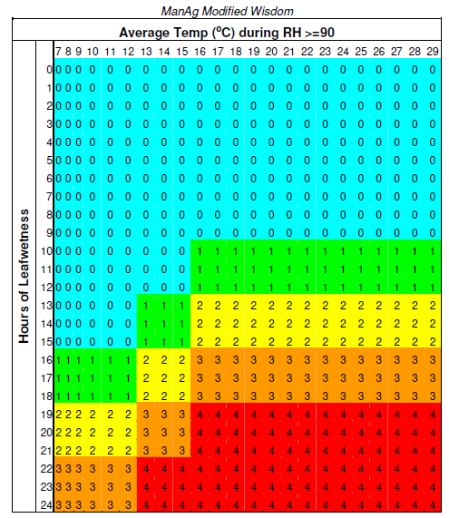

**Appendix 1.** Wisdom model showing the risk of disease severity as a result of humidity and temperature

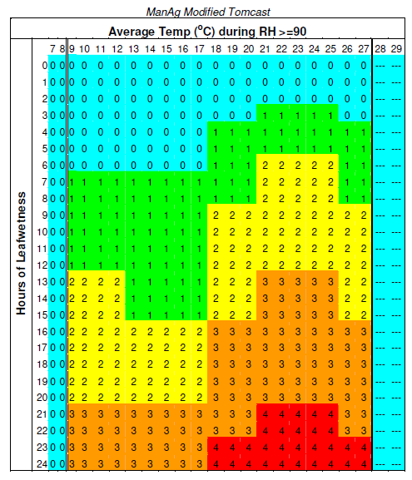

**Appendix 2.** TomCast model showing the risk of